

**ADITYA ENGINEERING COLLEGE**

**TITLE:** TECHNICAL HUB EVENT MANAGEMENT SYSTEM

**Team No:**07

**Team Members:**

21A91A04I1 ACHANTA KAVYA SRI FSD

21A91A04M8 NALLAMILLI BHUMIKA REDDY FSD

21A91A04O7 RONGALA LAKSHMI PAVANI FSD

21A91A04P5 THUMMAPALA PAVITHRA FSD

21A91A05A2 THUMMAPALA HARIKA CLOUD

21A91A05A4 YALLA SRI SURYA DIVYA CLOUD

**CONTENTS**

**Title**

Problem Overview

Project Description

Project Implementation

Technologies Used

Functionalities

Cloud Services

Conclusion

**Project Overview:**

The Technical Hub Event Management System project aims to develop a comprehensive, user-friendly platform that streamlines the entire event management process. By automating key tasks such as event creation, registration, ticketing, and participant management, the EMS will enhance operational efficiency and improve the overall experience for organizers and attendees. The system will integrate with social media and marketing tools to boost event promotion and offer real-time on-site management capabilities through a mobile app. Additionally, post-event analytics and reporting features will provide valuable insights for continuous improvement. Designed to be scalable and reliable, the EMS will support events of all sizes, ensuring a seamless, efficient, and successful event management experience.

**Objective:**

* **Automation**: Minimize manual intervention by automating routine tasks such as registration, scheduling, and communication.
* **Efficiency**: Improve the efficiency of event management processes, reducing time and resource consumption.
* **User Experience**: Enhance the experience for event organizers and participants through intuitive interfaces and reliable functionalities.
* **Scalability**: Ensure the system can handle events of various sizes, from small meetings to large conferences.

**Key Requirements:** The Event Management System (EMS) must efficiently handle the full spectrum of event-related activities. Key requirements include a robust event creation and planning module, allowing users to set up events with customizable templates, schedule dates and venues, and manage budgets and resources.

**Expected Outcome:** This project aims to deliver a comprehensive solution that addresses the diverse needs of event management, making it easier, faster, and more effective to organize successful events.

**Project Description:**

The Technical Hub Event Management System is designed to streamline the entire lifecycle of event planning and execution, catering to the needs of organizers and participants alike. This system automates routine tasks such as registration, scheduling, and communication, enhancing efficiency and minimizing manual intervention. Key features include customizable event creation templates, an online registration and ticketing system with various pricing options and secure payment processing, and a centralized participant management database. The EMS also integrates with social media and email marketing platforms for effective event promotion, and offers on-site management tools like mobile app-based check-in, real-time updates, and badge printing. Post-event, the system provides detailed analytics and reports on attendance, revenue, and participant feedback to help organizers evaluate success and identify areas for improvement. Built on a scalable technology stack, the EMS ensures reliable performance for events of all sizes, delivering a seamless and efficient experience for all users..

**Implementation:**

We implemented this website by creating a events list that are going to be conducted and which had completed in the past.

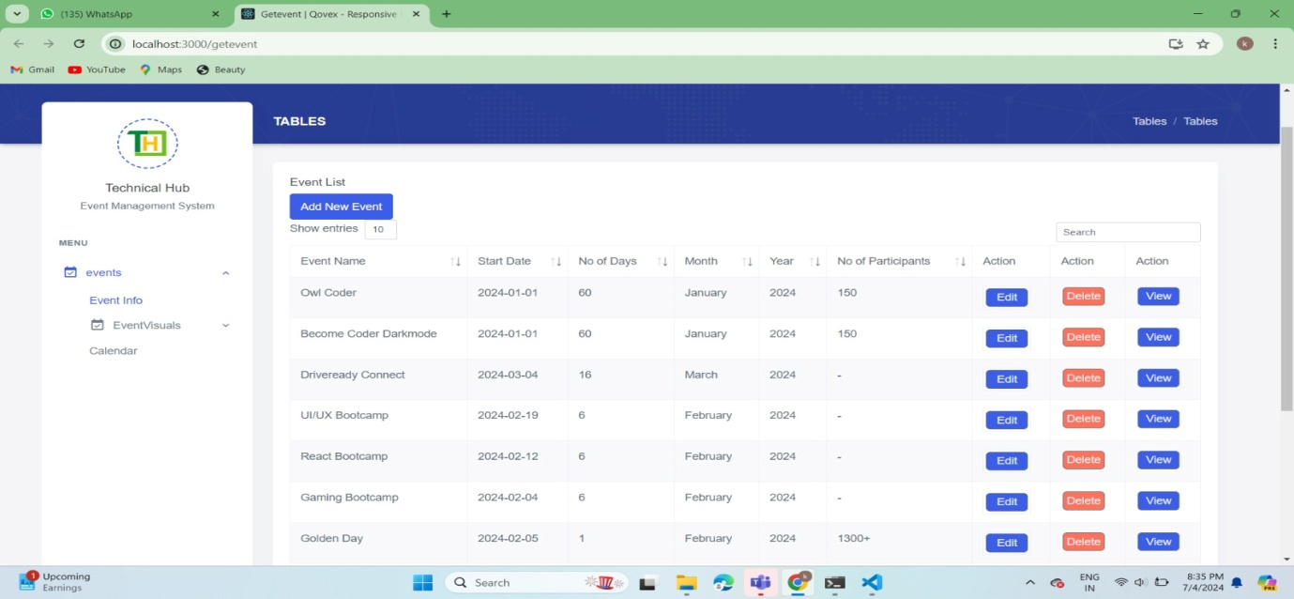

By clicking on the event info the data of all events will be displayed which is completed. Users have the flexibility to edit or delete project details as needed, ensuring the information is always current and relevant .If we want to add the upcoming events by clicking on the add new event, a form will be displayed as shown below.

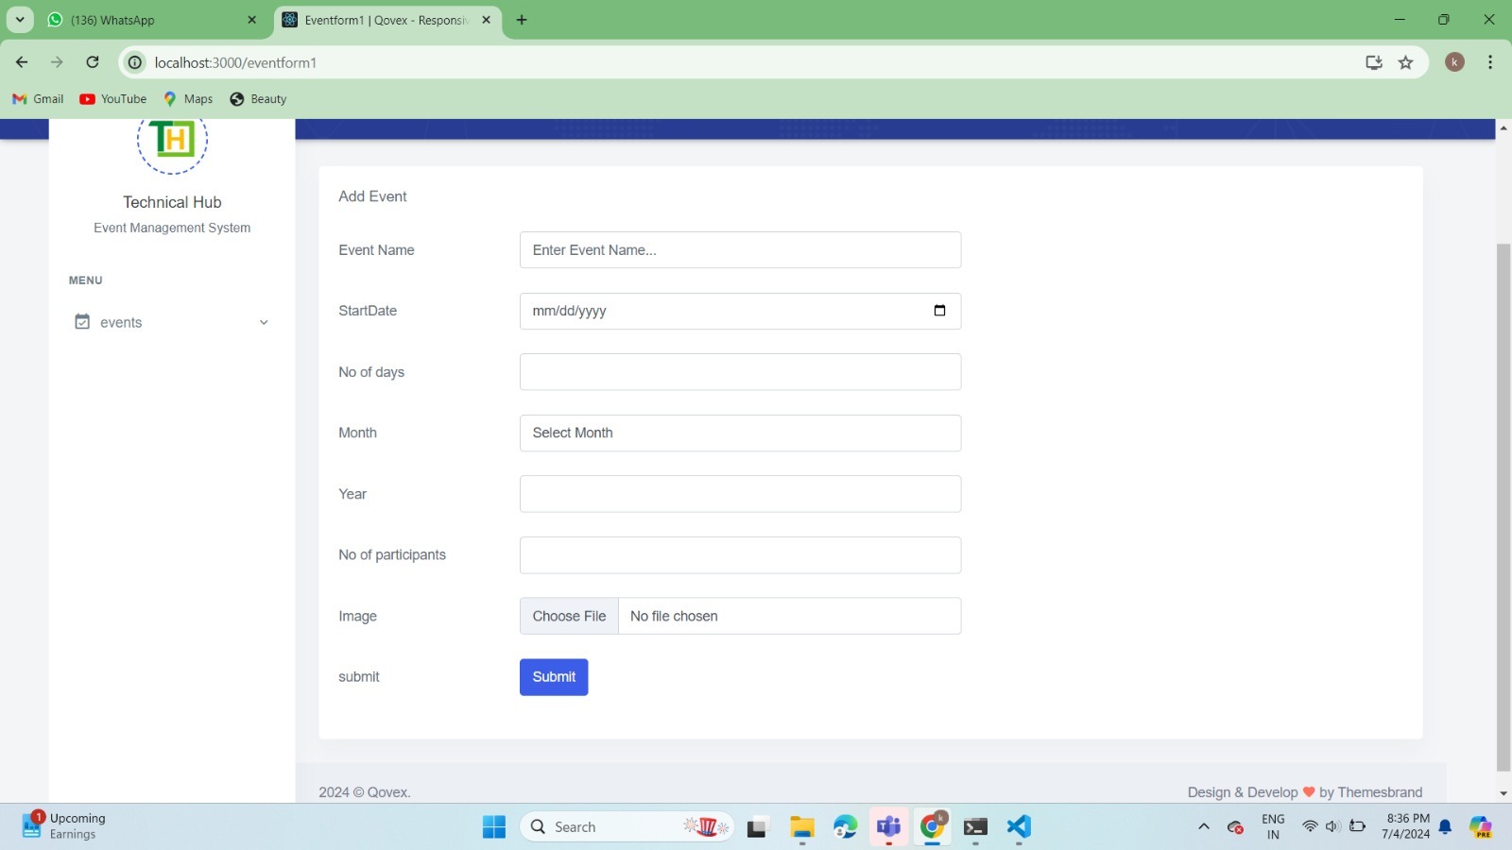

Users can easily view the image of a particular event by clicking on the view.

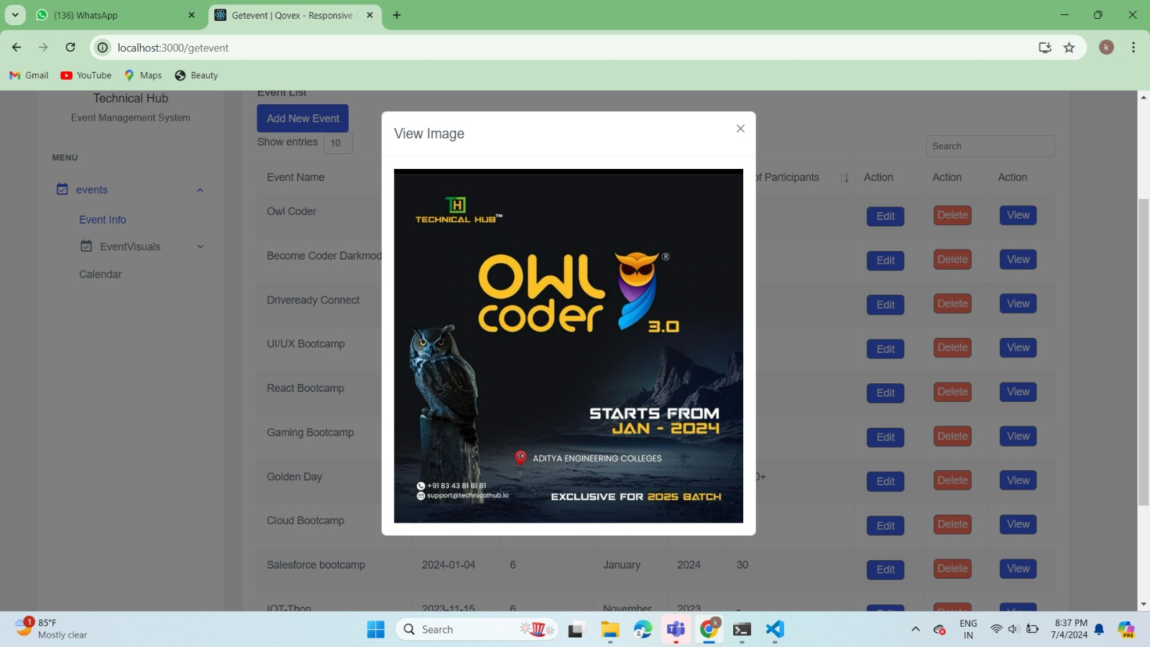

All the recently occurred events can be shown in the EventVisuals. Event Visuals shows the information about the event by clicking on the more info.

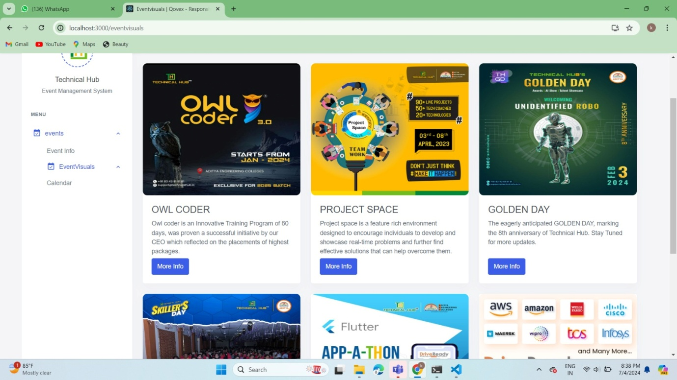

On the backend, we stored all project information in a robust database, ensuring data integrity and security. This setup allows for efficient data retrieval and management, supporting the platform's smooth operation. The database structure is designed to handle numerous projects and users simultaneously, maintaining performance and reliability. By centralizing project details in this manner, the website enhances organization, collaboration, and productivity within the technical community.

**Technologies Used:**

**Frontend:**

Javascript

Html

CSS

React js

**Backend:**

Node js

Mongodb

Express js

**Functionalities:**

1. **Project Listing:**
   * Users can view a comprehensive list of all events stored within the technical hub, categorized by type owlcoder, project space, golden day , etc.
2. **Project Overview:**
   * Upon clicking on a project title, users are presented with a clear overview displayed in five columns: "Team Members," "Mentor," "Requested," "In Progress," and "Done."
3. **Progress Tracking:**
   * Each event is easily trackable through the platform, allowing users to monitor progress from initiation to completion.
4. **Real-time Updates:**
   * Users can edit and update project details, ensuring that information remains current and reflective of the project's status.
5. **User Management:**
   * Users can access all the data relevant to the events and add the data of all the upcoming events. Only the particular user can edit and delete the event details.

**CLOUD SERVICES :**

**OCI Compute Instances**

Once you've found the Automation Anywhere template or image on the Marketplace, you can deploy it on OCI Compute instances

**Networking Services**

Depending on your deployment requirements, configure networking services such as VCN, subnets, security lists, and internet gateways to ensure connectivity for your Automation Anywhere deployment.

**Storage Services**

You may need storage services like Object Storage or Block Volumes to store data and artifacts required by your Automation Anywhere bots**.**

**Integration Service**

Oracle Cloud offers integration services that allow you to integrate Automation Anywhere with other Oracle Cloud services or third-party applications

**Conclusion:**

The Technical Hub Event Managemet System serves as a comprehensive solution for managing events within technical hubs. It centralizes all event-related data, including details on when the event has been started, how many days event has occured, how many number of students participated in the particular event, ensuring that information is easily accessible and up-to-date. The implementation of an event management system offers a comprehensive solution for organizing and managing events effectively. This system streamlines the various aspects of event planning, execution, and evaluation, making the process more efficient and user-friendly.

**Main Motto: "Streamlining Event Management for Technical Hubs "**

Top of Form